Case Study II: Low Level Design

Introduction
Distance education students may want to arrange to get together to work on this case study.
In the previous case study you should have come up with
- A Use case diagram
- Storyboards for one or more use cases, and
- A list of possible domain classes for the project
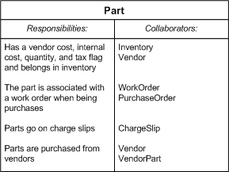
In this case study you are to develop a detailed design specification for the domain classes in your application. Remember that domain classes are those classes that deal with objects in the "problem" domain. In this case, they are going to be classes like an Employee class. GUI classes are not domain classes.

CRC Cards
Take the list of domain classes that you developed in the first case study. For each class on your list, create a CRC card. The figure on the right shows a sample CRC card for a "Part" class. Recall that on the left hand side of the card you write down "Responsibilities", that is, things that the class is responsible for. On the right hand side of the card you write down "Collaborators", or other classes that this class depends on to do its job. Look for strong cohesion in your designs and minimum dependence on other classes.
When you have finished, lay out all of your CRC cards on a table or desk. Now walk through your storyboards from Case Study I, and make sure that you have all of the domain classes that you need to satisfy your storyboard, and that they have the right functionality. If you are missing any classes, create CRC cards for them.

Class Diagram
Create a class diagram that includes all of the domain classes that you have come up with. Show all inheritance and composition relationships.

Header Files
Finally, create the header files for your domain classes.

Test Plan
Come up with a test plan to test your domain classes.

